**Terna Engineering College**

**Computer Engineering Department**

Program: Sem VII

**Course: Artificial Intelligence & Soft Computing (AI&SC)**

**Faculty: Rohini Patil**

LAB Manual

PART A

**Experiment No. 01**

**A.1 Aim:** Identify a problem statement relevant to AI and describe its PEAS Descriptors with its Properties.

**A.2 Prerequisite:** Software Engineering, System Analysis, Understand different types of agents.

**A.3 Outcome:**

**After successful completion of this experiment, students will be able to**

1. Understand, identify and analyse the problem, implement and validate the solution for the given task environment.
2. Applying fundamental engineering concepts appropriate to the discipline.
3. Potential to formulate and solve engineering problems in identifying the task environment.

**A.4 Theory:**

An agent is something that perceives and acts in an environment. The agent function for an agent specifies the action taken by the agent in response to any percept sequence. An agent is anything that can be viewed as perceiving its environment through sensors and acting upon that environment through actuators.

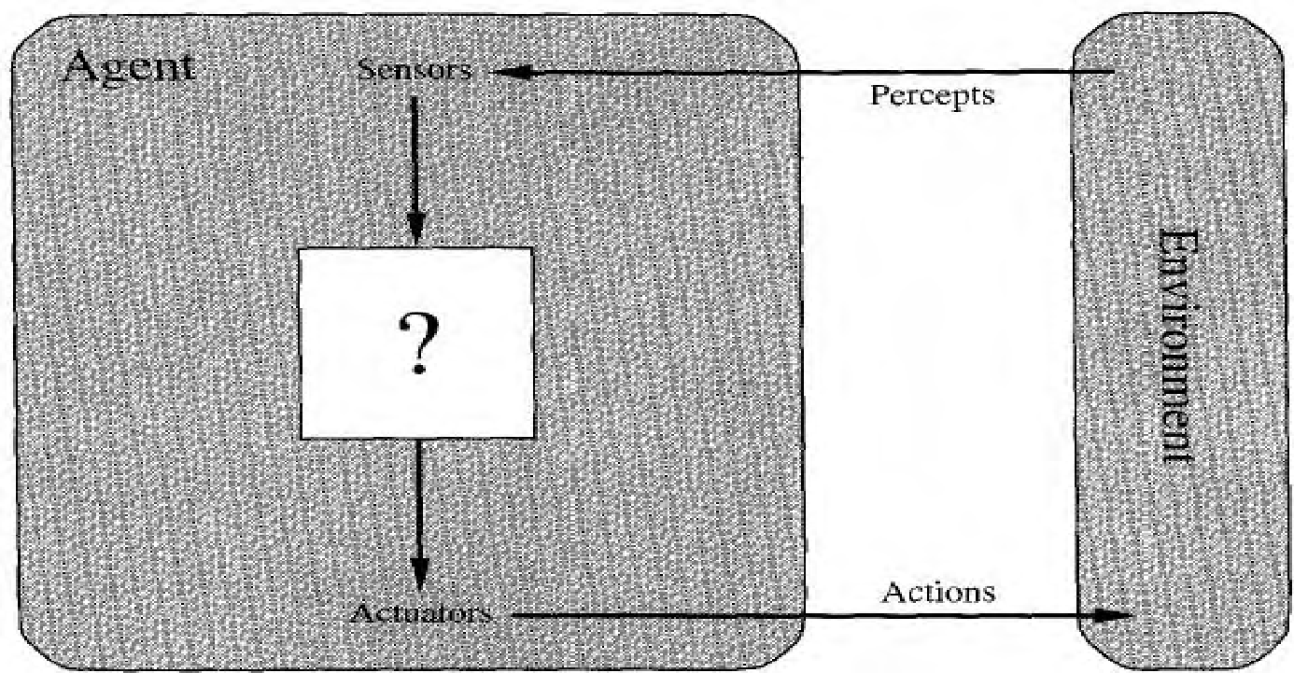

**Figure**: Agents interact with environments through sensors and actuators.

A performance measure embodies the criterion for the success of an agent's behaviour. When an agent is plunked down in an environment, it generates a sequence of actions according to the percepts it receives. This sequence of actions causes the environment to go through a sequence of states. If the sequence is desirable, then the agent has performed well.

A rational agent acts so as to maximize the expected value of the performance measure, given the percept sequence it has seen so far. A task environment specification includes the performance measure, the external environment, the actuators, and the sensors. In designing an agent, the first step must always be to specify the task environment as fully as possible. Task environments vary along several significant dimensions. They can be fully or partially observable, deterministic or stochastic, episodic or sequential, static or dynamic, discrete or continuous, and single-agent or multiagent.

The task environment for an agent is comprised of PEAS (Performance measure, Environment, Actuators, Sensors)

PEAS specify the setting of an intelligent agent:

**P: The performance measure defines the degree of success.**

**E: What does the agent know about the environment?**

**A: The actions that the agent can perform.**

**S: Everything that an agent has perceived so far through its sensors.**

**Environment properties:**

* **Fully (vs. partially) observable:** An agent’s sensors give it access to the complete state of the environment at each point in time.
* **Deterministic (vs. stochastic):** The next stage of the environment is completely determined by the current state and the action executed by the agent.
* **Episodic (vs. sequential):** The agent’s experience is divided into atomic “episodes” (in which the agent perceives then performs one action), and the choice of action in each episode depends only on the episode itself.
* **Static (vs. dynamic):** The environment is unchanged while an agent is deliberating. (The environment is semi-dynamic if the environment itself does not change with the passage of time but the agent’s performance score does.)
* **Discrete (vs. continuous):** A limited number of distinct, clearly defined percepts and actions.
* **Single-agent (vs. multiagent):** An agent operating by itself in an environment.

**Procedure/ Program:**

Example of Agent types and their PEAS (performance, environment, actuators, sensor) Descriptions.

1] **English Tutor Example: PEAS**

* Agent: Interactive English tutor
* Performance measure: Maximize student's score on a test
* Environment: Set of students
* Actuators: Screen display (exercises, suggestions, corrections)
* Sensors: Keyboard
* English tutor: Observable: Partially Agents: Multi (why?) Deterministic: Stochastic Episodic: Sequential Static: Dynamic Discrete: Discrete

2] **Robot: PEAS**

* Agent: Part-picking robot
* Performance measure: Percentage of parts in correct bins
* Environment: Convey p, or belt with parts, bins
* Actuators: Jointed arm and hand
* Sensors: Camera, joint angle sensors

**PART B**

**(PART B: TO BE COMPLETED BY STUDENTS)**

***(Students must submit the soft copy as per the following segments within two hours of the practical. The soft copy must be uploaded on the Blackboard or emailed to the concerned lab in charge faculties at the end of the practical in case there is no Blackboard access available)***

| Roll No. 50 | Name: AMEY THAKUR |
| --- | --- |
| Class: BE-COMPS-50 | Batch: B3 |
| Date of Experiment: 27-07-2021 | Date of Submission: 27-07-2021 |
| Grade : |  |

**B.1 Document created by the student:**

***(Write the answers to the questions given in section 4 during the 2 hours of practice in the lab here)***

**Automated Teller Machine:**

An automated teller machine (ATM) is a type of computerised banking terminal that allows clients to conduct simple transactions without the assistance of a teller or branch staff. Most ATMs allow anybody with a credit or debit card to withdraw cash.

PEAS stands for Performance Measures, Environment, Actuators, and Sensors.

* **Performance Measure:** Safety, Time, Withdrawal of Cash, Updation of Bank Balance.
* **Environment:** Bank, Staff, Persons, Cards.
* **Actuators:** Card Dispenser, Display Screen, Receipt Printer.
* **Sensors:** Keypad, Card Reader.
* **Card reader:** This part reads the chip on the front of the card or the magnetic stripe on the back of the card.
* **Keypad:** The keypad is used by the customer to input information, including personal identification number (PIN), the type of transaction required, and the amount of the transaction.
* **Cash dispenser:** Bills are dispensed through a slot in the machine, which is connected to a safe at the bottom of the machine.
* **Printer:** If required, consumers can request receipts that are printed here. The receipt records the type of transaction, the amount, and the account balance.
* **Screen:** The ATM issues prompts that guide the consumer through the process of executing the transaction. Information is also transmitted on the screen, such as account information and balances.

**Task Environment and its types:**

| **Task Environment** | **Observable** | **Deterministic Episodic Static Discrete** | **Agents** |
| --- | --- | --- | --- |
| Cards, People | Partially | Deterministic Episodic Dynamic Discrete | Single |
| Patient, Staff | Partially | Stochastic Sequential Dynamic Continuous | Single |
| Carpet, Table | Fully | Deterministic Sequential Dynamic Continuous | Single |
| Bins | Partially | Stochastic Episodic Dynamic Continuous | Single |
| Roads, Pedestrians | Partially | Stochastic Sequential Dynamic Continuous | Multi |
| Classroom, Student | Partially | Stochastic Sequential Dynamic Discrete | Multi |
| Operators | Partially | Stochastic Sequential Dynamic Continuous | Single |

**B.2 Observations and learning:**

**(*Students are expected to understand the selected topic Prepare a flow of the steps defined in the paper)***

An agent is something that may be thought of as sensing its surroundings through sensors and acting on them through actuators. The agent's surroundings are referred to as an environment in artificial intelligence. The agent receives input from the environment via sensors and outputs to the environment via actuators.

We looked at the PEAS System, which is designed to group similar medicines together. The PEAS system calculates the agent's performance based on the environment, actuators, and sensors. Rational Agents make up the majority of the top-performing agents. We've also determined the task environment.

**B.3 Conclusion:**

*(****Students must write the conclusion as per the attainment of an individual)***

We have effectively grasped the AI idea of Agents, the PEAS System, and the many sorts of Agent Environments.

**B.4 Question of Curiosity:**

**Q1) Explain PEAS Descriptors in detail.**

**ANS:**

PEAS stands for Performance Measures, Environment, Actuators, and Sensors.

* Performance Measure: If the objective function is to judge the performance of the agent. things we can evaluate an agent against to know how well it performs. For example, in the case of a pick and place robot, no of correct parts in a bin can be the performance measure.
* Environment: It is the real environment where the agent needs to deliberate actions. what the agent can perceive.
* Actuators: These are the tools, equipment or organs using which agent performs actions in the environment. This works as the output of the agent. what an agent can use to act in its environment.
* Sensors: These are tools, organs using which agent captures the state of the environment.

**Q2) Explain Current trends in AI.**

**ANS:**

A survey published by the McKinsey State of AI in November 2020 suggested that at least half of the organizations have adopted AI functions in their organization. Businesses are more digitally connected than ever before since the lockdown and work from home were put into action.

Current Trends in AI:

1. Greater Cloud and AI collaboration

* Artificial Intelligence will play a significant role in the broad adoption of Cloud Solutions in 2021. Through the deployment of artificial intelligence, it will be possible to monitor and manage cloud resources and the vast amount of available data.

1. Large scale adoption of AI in the IT industry

* We have seen continuous growth in the adoption of AI within the IT industry. Predictions are that organizations will use AI in production and start using them on a large scale. With the help of artificial intelligence, an organization can get ROI in real-time. This means that organizations will see their efforts being paid off.

1. Augmented Processes have become increasingly popular

* Artificial intelligence and data science will prove to be a part of a bigger picture when it comes to innovation and automation in 2021. Using Artificial Intelligence, software development processes can be optimized, and we can look for a wider collective intelligence and improved collaboration.

1. Voice and Language Driven intelligence

* Particularly in customer care centres, the increase in remote working has driven a great opportunity to adopt NLP or ASR (automated speech recognition) capabilities. Less than 5% of all customer contacts are routinely checked for quality feedback. Due to the lack of one-on-one coaching, organizations can use artificial intelligence to complete routine quality checks on customer understanding and intent to ensure continued compliance.